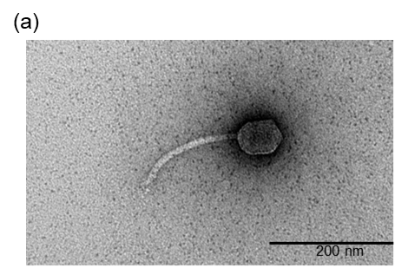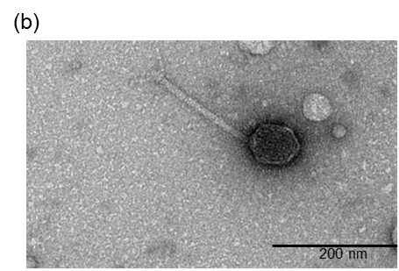
Fig. S1. TEM images of (A) CSP1C produced in E. coli MG1655 and (B) CSP1C produced in E. coli MG1655 harboring pACYC184::CSP1_020 for CSP1_020 complementation.

