Supple Data 8. Example of the polytomy-resolving process performed using FunVIP
To assess the effectiveness of the polytomy-resolving process, we compared FunVIP results obtained with and without polytomy-resolving process. To generate FunVIP result without polytomy-resolving, the FunVIP result directory of the Aspergillus section Terrei dataset, using the accurate preset and distance cutoff 0.01, was copied and was rerun (See “500_Polytomy_resolve” directory of the archived data in Zenodo repository). Original trees and edited ITS trees from both runs were compared to evaluate performance of the polytomy-resolving process. The polytomy-resolving process successfully rearranged zero-length branches and resulted in a clearer final visualization (Fig. S8.1).
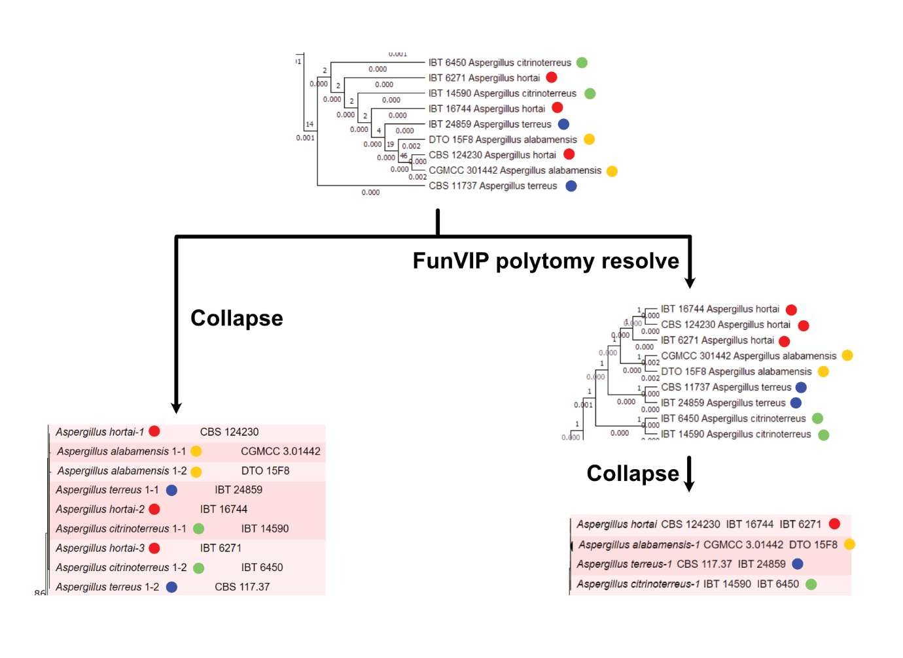
Fig. S8.1. Example of the polytomy-resolving process performed with FunVIP. ITS trees from the Aspergillus section Terrei dataset are compared by applying the polytomy-resolving option.

