Supple Data 2.5. Algorithm for outgroup database sequence sorting (Fig. S2.5)
The most appropriate outgroup, denoted as t, is automatically selected from the database. It is the closest group of sequences to the assigned taxonomic group, while still being distinctly different from assigned ingroup taxonomic group. Let t_{k} represent the sequences of the outgroup taxonomic group, i_{x} the sequence of the ingroup taxonomic group, B_{pq} the bitscore value between sequences p and q, and c the outgroup offset. The outgroup taxonomic group t was chosen based on the following criterion:
$$t=argmin \{min(B_{i_{x}t_{k}}) | max\left(B_{i_{x}t_{k}}\right)<\min\left(B_{i_{x}i_{y}}\right)-c\}$$
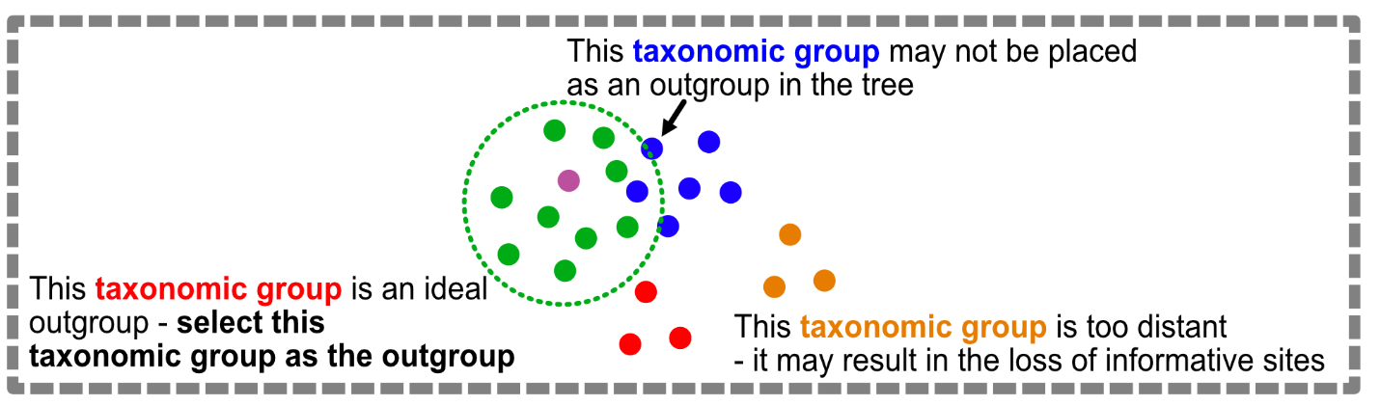
Fig. S2.5. Infographics illustrating the algorithm for outgroup database sequence sorting.

