Supple Data 2.2. Definition of sequence-set in FunVIP (Fig. S2.2)
Properties
Taxonomic group | : | Specific taxa above species level for targeted analysis
 |  | e.g. Fuscoporia (genus), Hymenochaetales (order)
Genetic marker | : | Genetic element (including coding and non-coding regions) for analysis
 |  | e.g. ITS, LSU, BenA, RPB2
Contents
Query | : | Selected input sequence that is targeted for analysis
Database | : | Selected input sequence from a database consisting of Ingroup, Suspicious, and Outgroup sequences
Ingroup | : | Database sequence annotated as Taxonomic group of the sequence-set.
 |  | e.g. Fuscoporia sequence
Suspicious | : | Database sequence not annotated as belonging to the Taxonomic group but can potentially be an Ingroup.
 |  | e.g. Fuscoporia sequence annotated to Sanghuangporus
Outgroup | : | Database sequence that is confirmed not to belong to the Taxonomic group.
 |  | e.g. Hydnoporia sequence
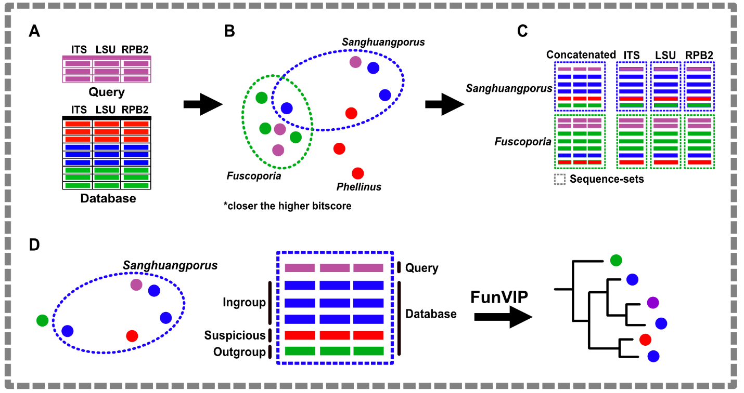
Fig. S2.2. Infographics illustrating the definition of sequence-sets in FunVIP. (A) Representation of the input query file and database file. (B) BLAST/MMseqs search space, where the proximity of sample pairs indicates a higher bitscore. (C) Visualization of the generated sequence-sets. (D) Key elements of the sequence-set and their respective roles in the final phylogenetic analysis.

